FlyU airline

FlyU is an airline company. They keep records of the flights that leave each airport. They record planned departure and arrival times, actual departure and arrival times from and to each airport. Information on which passengers are on each flight is recorded, some passengers will need a number of flights to reach their destination – this is known as a trip and also includes details of return flights. Also recorded is the lead and deputy pilot for the flight.

Complaints raised by passengers are recorded against flights, passengers are required to raise a complaint against each flight if they miss connections due to delays.

The system provides information for the airline on flight delays which they use in their planning and customer complaints service.

1. Design an ERD for the system
2. Design SQL for the required reports.

Claims star schema model

Now you have new type of database. This model is know as a star schema model – note it is still a relational database model.

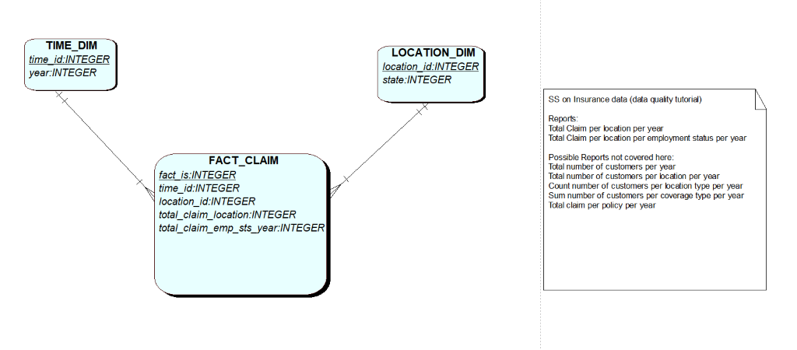

Run the Claims_SS script in apex and look at the data in each of the above tables.

Answer these questions:

* On the fact_claim table how many claims are there for Arizona in 2011?
* How many years of data does this database include?
* Are there any claims assigned to unknown states?

Now write SQL on the SS model to:

* SELECT the number of claims for 2011 in Arizona.
* SELECT the number of claims per state in 2011
* SELECT the number of claims per state per year